MQTT_WIFI

kambergArjan

ServerInstelligen

---------------------

Arjan Tn09Q4233

MQTT Router

-----------------

Arjan Tn09Q4233

mqtt_wifi kambergArjan

<https://mosquitto.org/download/>

Download and install

Start cmd als administrator

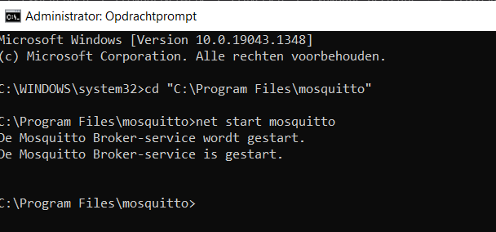

<http://mqtt-explorer.com/>

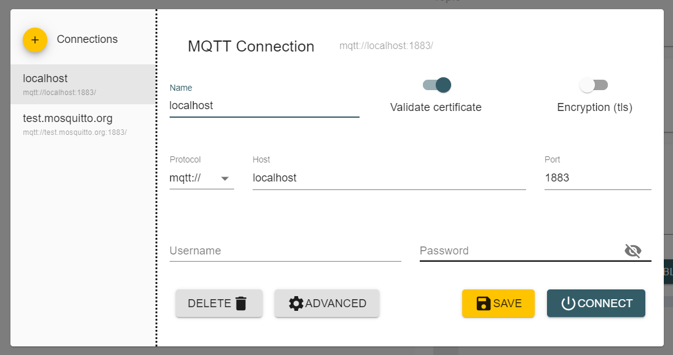

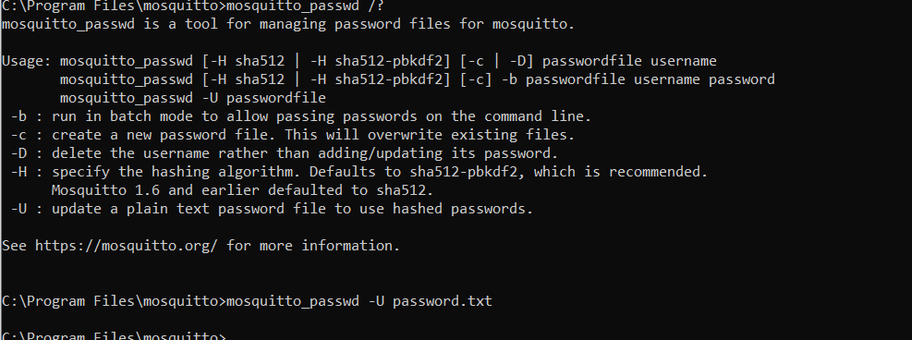



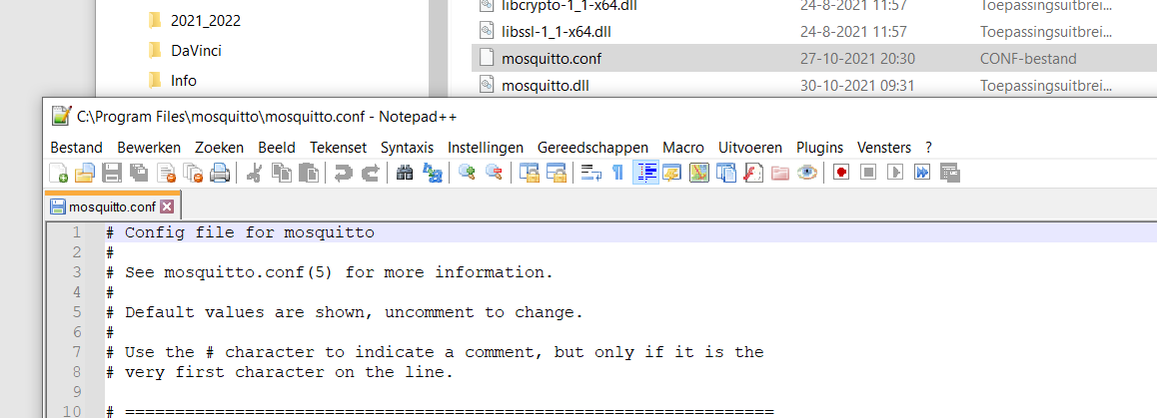

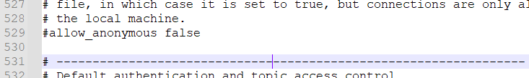

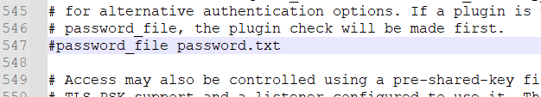

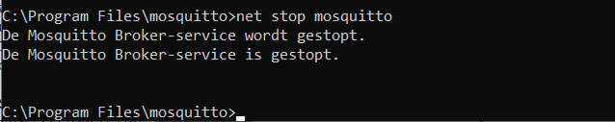

Open zetten naar buiten….??????

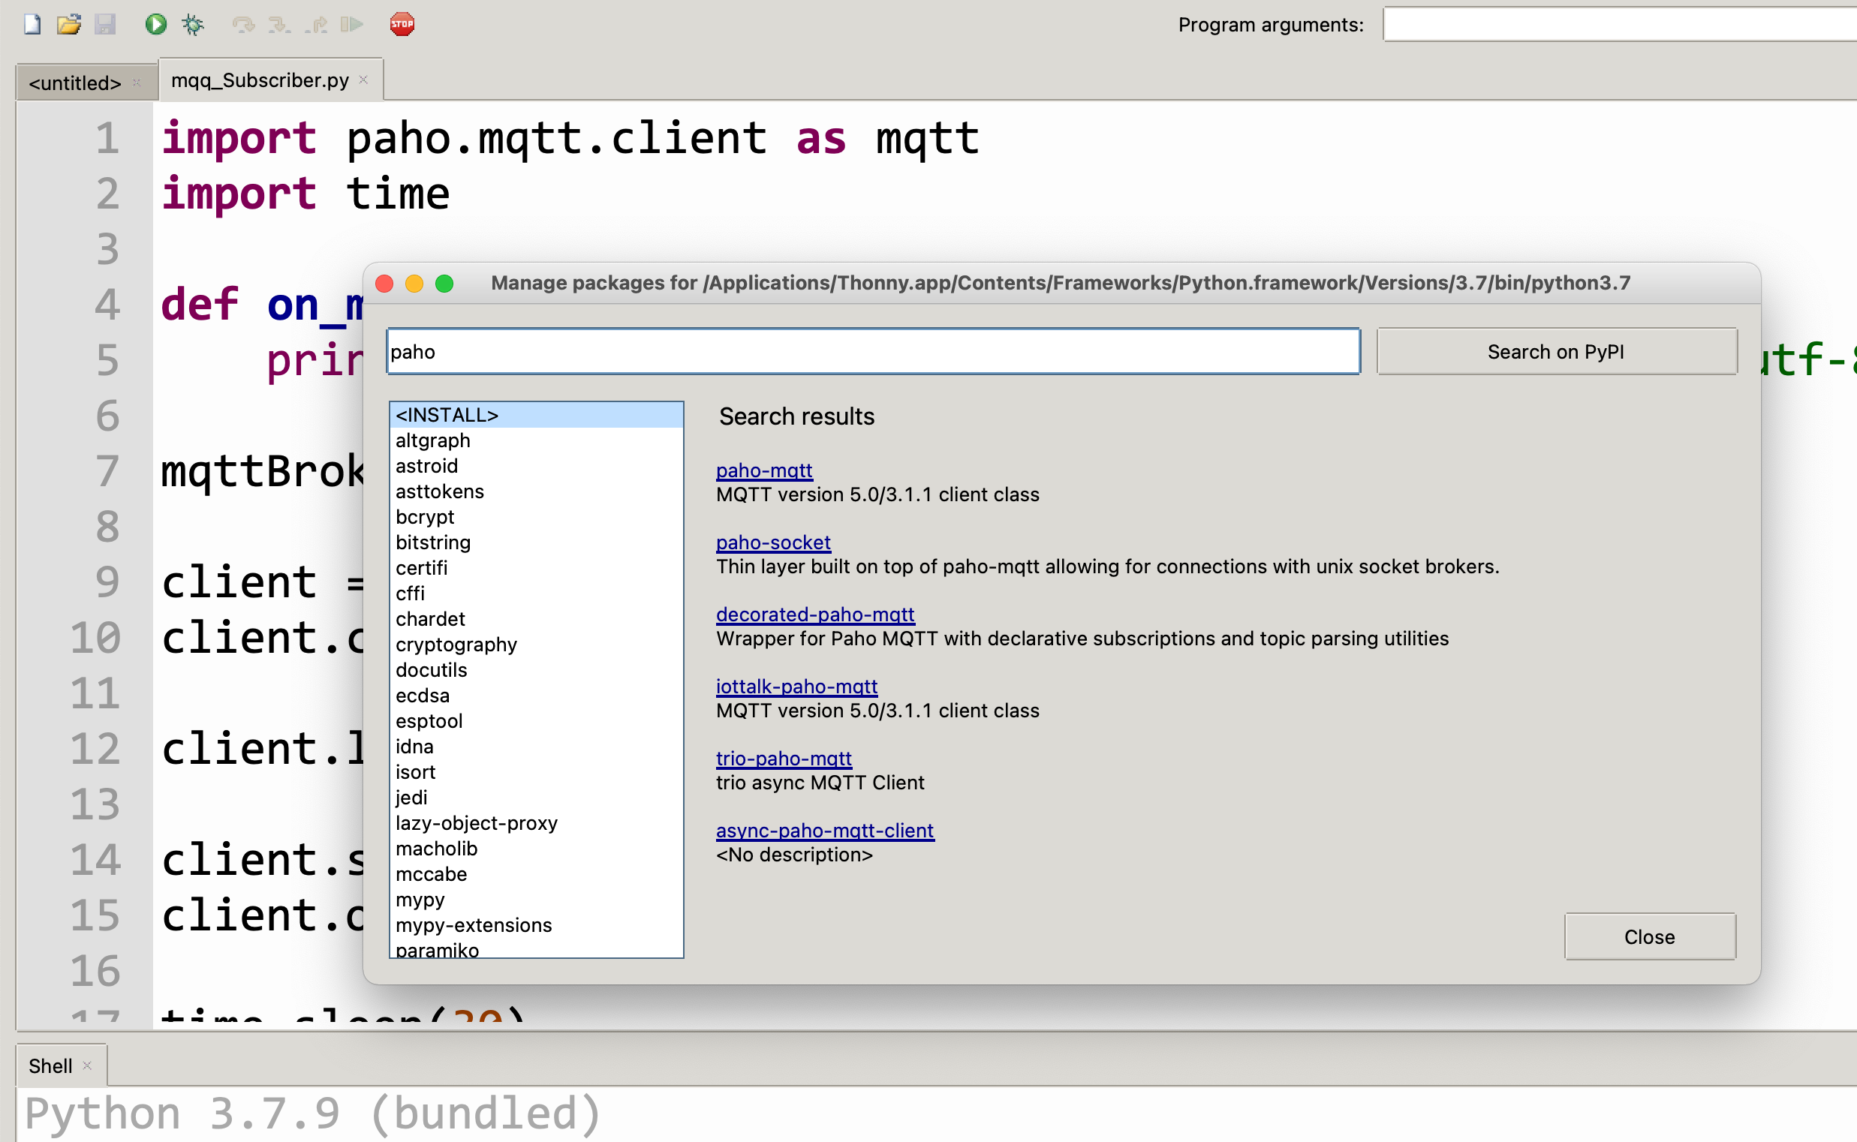

mqtt.eclipse.org

\

Ipconfig

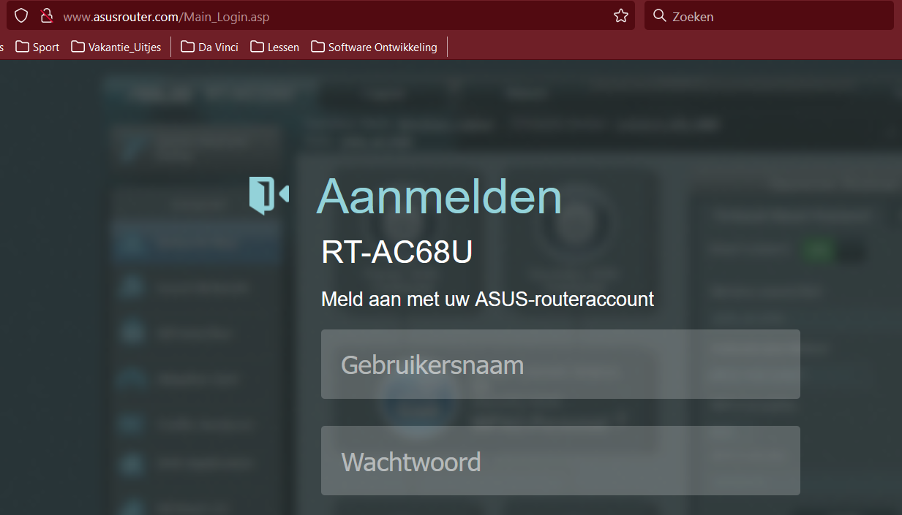

User/ww : Arjan/Kamberg  
SSID/WW : MQTT/00000000 ( 8 nullen)

